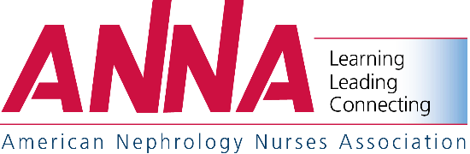

Function Space Request Form
2020 National Symposium – April 19-22, 2020
Caribe Royale Orlando
Orlando, Florida

Exhibiting Firm Requesting Space

Contact Person Title

Address

City State ZIP

Phone FAX E-mail

Function or Event Name

Onsite Contact & Phone Number

Function Date(s) and Times(s)

Expected Attendance Meeting Space Set-Up

Purpose

Requested Location: Caribe Royale Orlando

Signature Date

Please return form to: American Nephrology Nurses Association
c/o Anthony J. Jannetti, Inc.
East Holly Avenue, Box 56
Pitman, NJ 08071-0056
Attention: Rachel DeAngelo, Conference Coordinator
Phone – 856-256-2430
E-mail – rachel.deangelo@ajj.com

*** FOR OFFICE USE ONLY***

Meeting Approved By Date of Approval
Location Date Assigned
Meeting Room Date/Time
Facility Contact Person Phone

